Computer Programming
April 6 – 10

What you will need:
Computer/device
Internet
School e-mail

What you will do:

M 4/6 | T 4/ | W 4/8 | Th 4/9 | F 4/10
Join our Computer Apps Team on Microsoft TEAMS  Make a Post in our TEAM Discussion Board | Reply to ONE classmate in TEAM Discussion Board | Get set-up on CodeHS.com  Learn how to use CodeHS | Learn how to use CodeHS | All Tasks DUE Friday at 3:00
Use the boxes below to CHECK when above task is completed (optional):

What you will learn:
Set-up an account on CodeHS.com and familiarize yourself with the site.

How you will complete your work:

Sign-Up:
Go to codehs.com/go to create your account and join your class with your class code: ADF85.
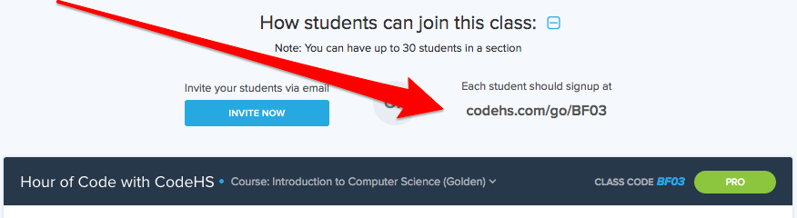
Our class code:
ADF85

Get to know CodeHS:
Click around. See what is available to you.
How you will turn-in your work:
You will not turn-in anything this week. You will get points for signing up. I will see that you sign-up and see what you clicked on.

Enroll in Computer Apps TEAM:
- FIRST: If you plan to use your PHONE or tablet, you must Download the Microsoft Teams app before you join the class; you can also use Microsoft Teams through your computer. Instructions are in your email.

- NEXT: You will have an invitation in your school e-mail to join our team. Follow the directions provided.

- EXPLORE our Team: Click on EVERY tab and open EVERY folder.

Make a POST in Computer Apps TEAM:
- Open the document that was sent in your email called Microsoft TEAM Instructions. Use this to help learn how to use TEAM.

- Once you open your Class, one the left side, click Discussion Board.

- Find the POSTS tab. Start typing in the box as shown below, hit enter or the arrow when done.

- Your post should be a nice message to class: Tell us what you’ve been doing, how you are, etc. Reply a kind response to at least TWO classmates by clicking REPLY located under their original post.

Select GENERAL on the left hand side to get back to our classroom.

“See” you next week!

